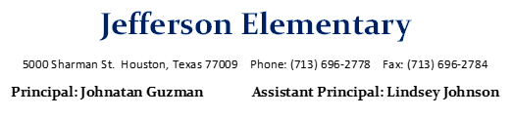

**In Attendance**

Mr. Ruiz – BIL Teacher

Ms. Ruiz – Explorer

Ms. Jimenez – Teacher

Ms. Genovese – Teacher

Ms. Copeland - Counselor

Ms. Gonzales – Resource

Ms. Fernandez – Secretary/Office Mgr.

Mr. Guzman - Principal

**Staffing**

* SLC Sped Teacher – we are still looking for a new sped teacher with the upcoming job fair
* Ms. Brown – has been reassigned to the HELC building however she is still in are apr which strains our budget
* Secretary – Ms. Fernandez will be looking for retirement Mr. Guzman has possibly found a possible replacement, who has 28 years of experience more information will come

Budget

* ESSER funds being used for academic tutorials at an increased rate of $50/hour. § ESSER funds allocated towards funding Summit (TELPAS & Science) programs, intervention resources, renewed subscription for STEMScopes §
* ESSER funds was used to fund March session of Camp Spark. We have received funding for 5 teachers and plan to invite Depending on the student permission forms turned in, we may use other school budget funds to additional teachers if necessary.
* Purchases for Next year- Technology, Furniture, Reading and Math resources, Motorized Gate, Planning

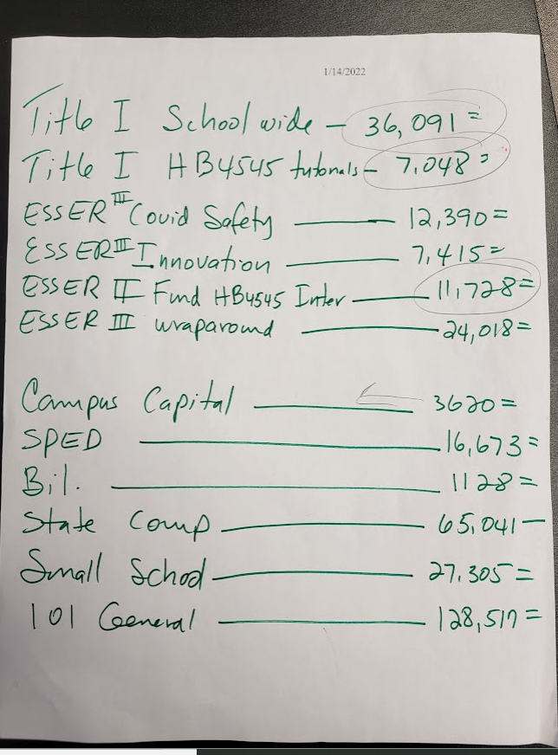

**School Culture**

* Upcoming events: Virtual Coffee with the Principal, Spring Festival (Cinco de Mayo) Tentative

**SIP**

* Board goals progress monitoring is taking place based on MOY testing and Snapshot DLA.

**Adjournment:**

Next Meeting Date: **TBD**